Pythagorean Theorem
Using GeoGebra

Quick Review:

What is the difference between the hypotenuse of a triangle and its legs?

__________________________________________________________________

What is the Pythagorean theorem formula?________________________________

Find the missing value of the following triangles using this formula.

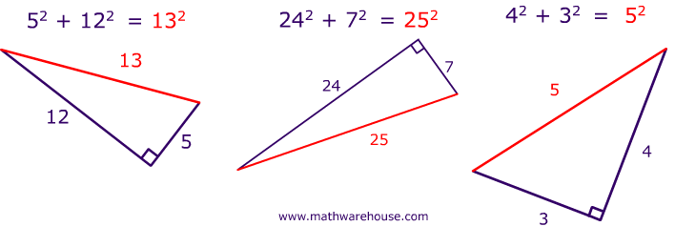

Part 1
- Using the segment tool, create line segment AB
- Find the semicircle tool. Click on point A and then click on point B
- Create a point C anywhere on your semicircle
  - Note: Make sure when you move point C that it stays on the semicircle
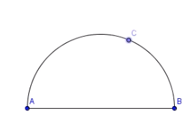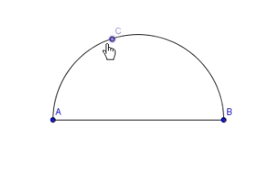
- Using the Polygon tool, connect points A, B, and C in a counterclockwise motion
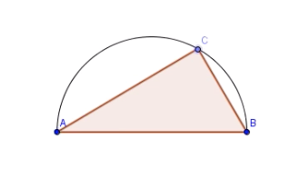
- On the left hand side of your screen, turn off the semicircle and line segment AB
- With the angle shortcut tool, find the measures of each angle
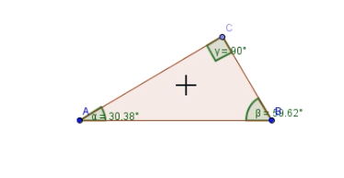
- Right click on the angle measurements and turn off the number measurements
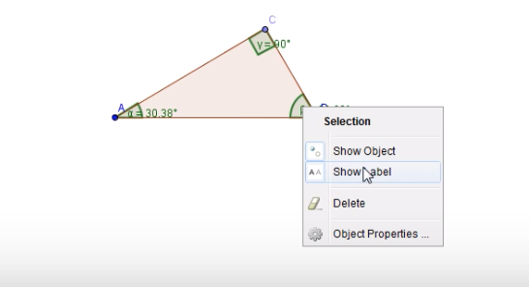

- Using the perpendicular line tool, click on segment BC, then click point C.

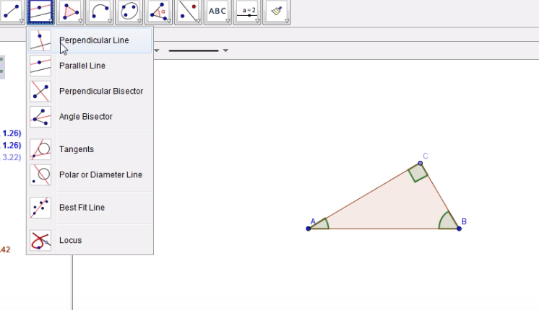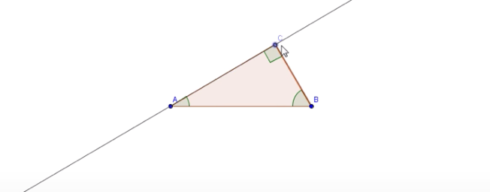

Repeat again, but this time click on point B

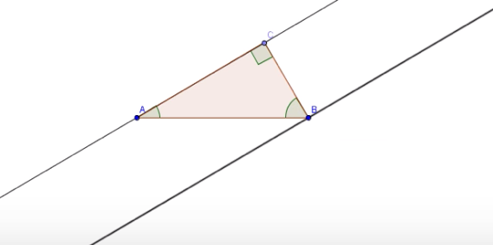

- Create a circle with center C and going through point B

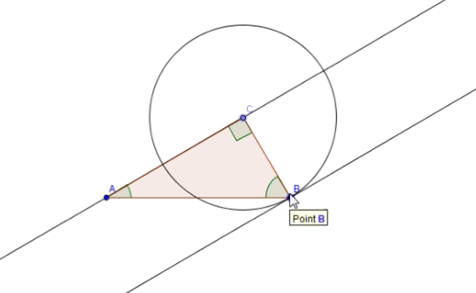

- Create point D by intersecting the parallel line AC with circle C
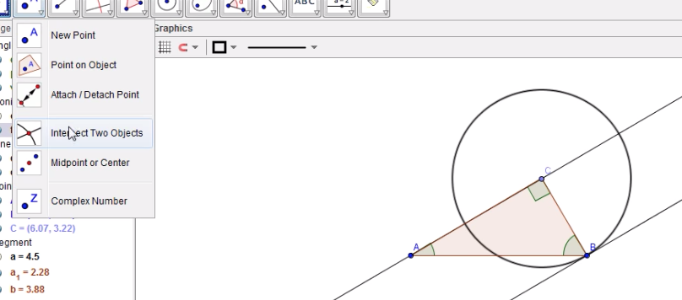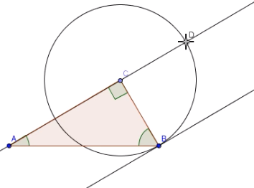

- Create a parallel line from BC to the point D
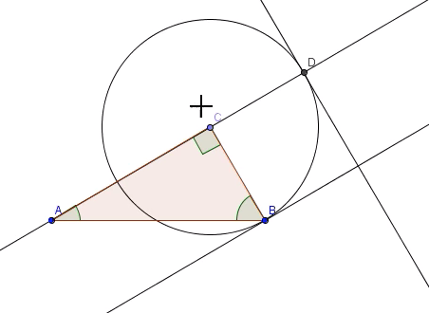
- Create point E where the parallel line you just created intersects the perpendicular line at B
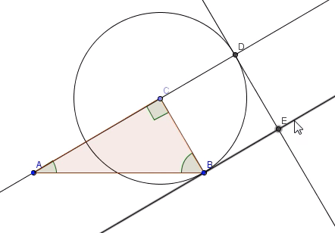

- Right click on all the lines and circle you just made, and turn them off, leaving just the two points
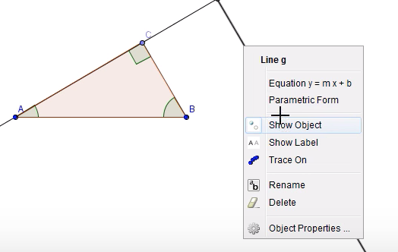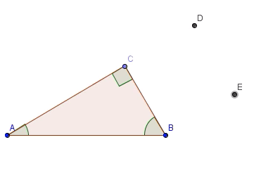
- Use the polygon tool again starting at point B in a clockwise direction to create a square
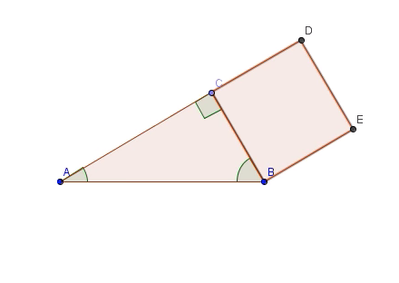

- Repeat steps 8-14 for the remaining sides of the triangle with the corresponding sides (see below)

- You now should have 3 different sized squares attached to each side of your triangle. Use the drag test to make sure the whole shape stays together

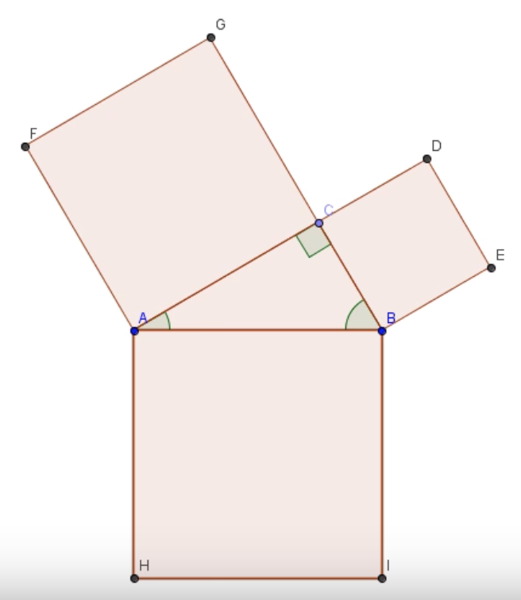

Part 2
- Next, you want to find the middle of each square. Use the midpoint tool and click on opposite points on the square. For example, clicking point C and Point E will give you the midpoint.
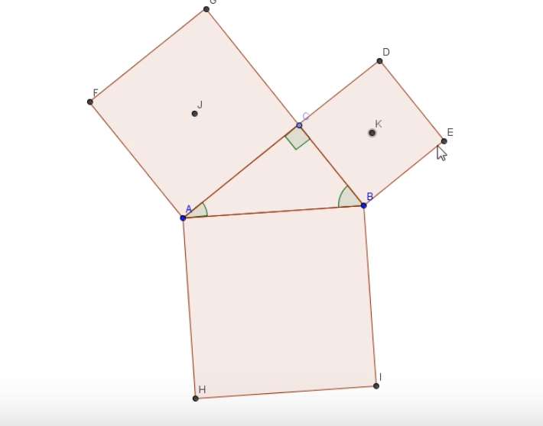

- Click on the tool at the top that says ABC to insert a text box.
  - The first drop down menu should say LaTeX formula. Make sure the box to the left of it is checked. In the drop down menu, highlight your mouse over Roots & Fractions and select $x^{a}$.
  - In the edit section of the window, replace the “x” with “a” and replace “a” with 2. Click OK.
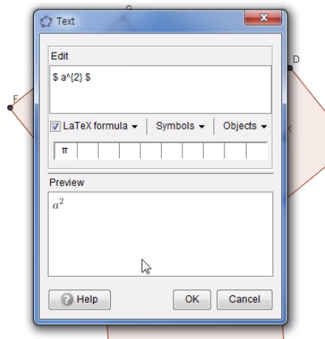
  - Right click on the text that was inserted. Click “object properties” and click position. Choose one of the midpoints for the squares attached to the legs of your triangle.
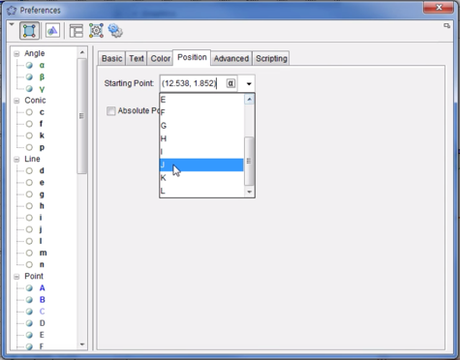

  - Repeat for “b” on the other leg. For “c”, make sure it is on the hypotenuse of the triangle, the side of across from the 90-degree angle.
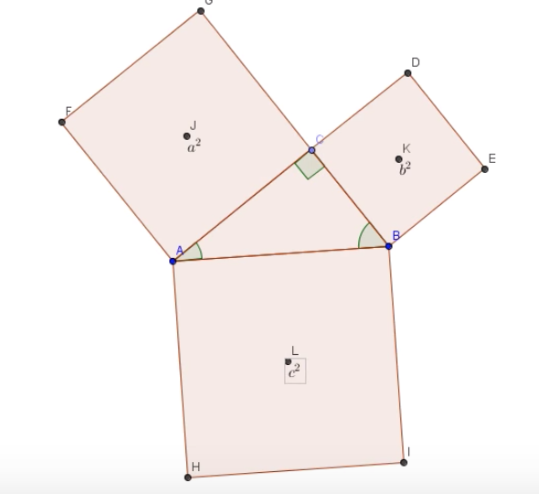

- Once you have attached the letters to the midpoint, you can turn off the original midpoints so only $a^{2}$, $b^{2}, and c^{2}$ is showing.

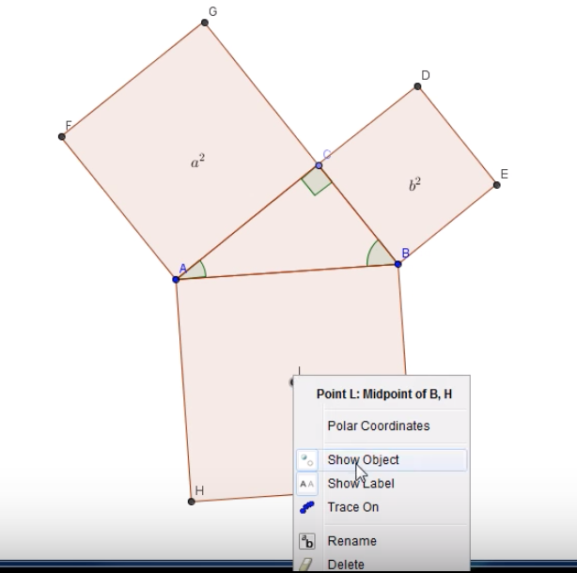

Optional: Click inside each square and click the dropdown arrow of the colored box. This allows you to change the fill color of each different object.

- Insert another LaTeX formula (look back at step 2). You can either write “$a^{2}+b^{2}=c^{2}$” all at once, or if you chose to color code your blocks, you can type them individually and change their font color to match corresponding square using the format painter tool.
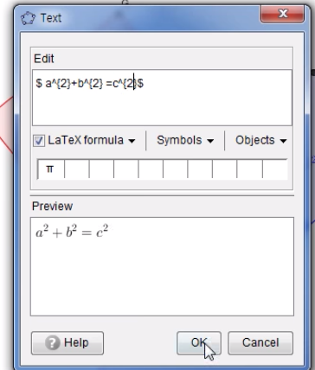

- In the input bar, type Area_a=a_1^2 to get the area of your square labeled $a^{2}$. Repeat this step for the other two squares, replacing the variables to the ones that correspond to each square.
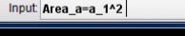

- Insert text and select the dropdown menu labeled “Objects” and select Area_a. Drag this underneath the $a^{2}$ of your formula. Do this again for both b and c.

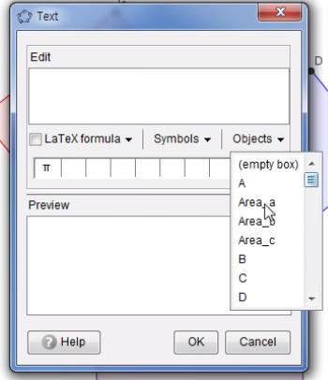

- Use the drag test again, but notice how your area numbers change as you do so.

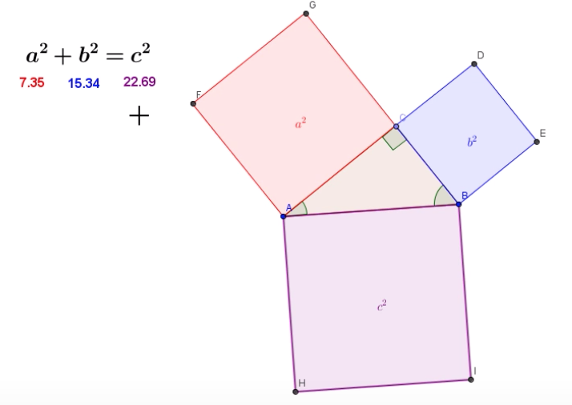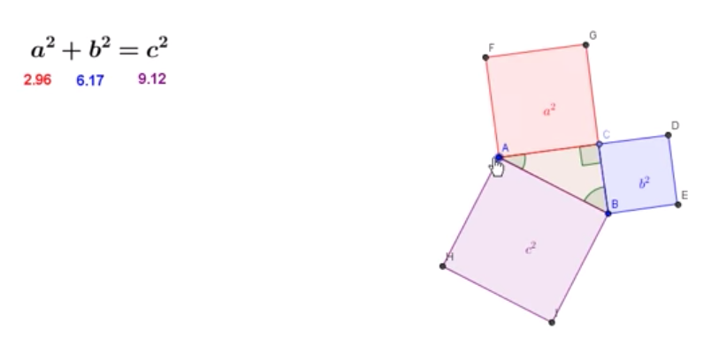

Practice
Using this interactive diagram, answer the following questions. (Do not use the formula!)

- If a=3 and b=4, what is c?___________________________________________

- If a=14 and c=20, what is b?_________________________________________

